[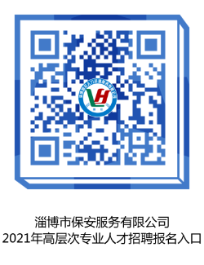](http://hrss.zibo.gov.cn/picture/0/32a729a0b72f43d2a9320e60084ccef4.png)