[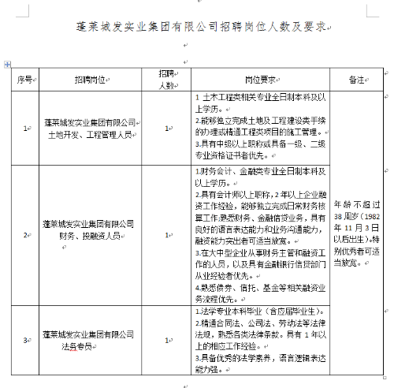](http://www.penglai.gov.cn/picture/0/bc3eab8f1fb444869893892e1f0739a6.png)